Handwritten Digit and Alphabet Recognition

Project Proposal



Supervisor
Sir Zeeshan Aslam

Submitted by

M. Moaz Nadeem
{01-134191-022}
Muhammad Arham khan
{01-134191-050}

Department of Computer Science,
Bahria University, Islamabad.

[1st March 2022]

Introduction
The handwritten character recognition is the ability of computers to recognize human handwritten digits. It is a hard task for the machine because handwritten digits are not perfect and can be made with many different flavors. The handwritten digit recognition is the solution to this problem which uses the image of a digit and recognizes the digit present in the image.

Objective
Implement a handwritten character recognition app using the MNIST dataset. Build a GUI in which user draw the digit and recognize it straight away.

Problem Description
The handwritten character recognition is the capability of computer applications to recognize the human handwritten characters. It is a hard task for the machine because handwritten characters are not perfect and can be made with many different shapes and sizes. The handwritten character recognition system is a way to tackle this problem which uses the image of a character and recognizes the character present in the image. Convolutional Neural Network model created using PyTorch library over the datasets to recognize handwritten character. Handwritten character Recognition is the capability of a computer to fete the mortal handwritten integers from different sources and classify them into 10 predefined classes (0-9), Alphabets both upper case (A-Z) and lower case (a-z) and symbols such as “+, -, *, /, ? etc.”.

Methodology
Convolutional Neural Network model created using PyTorch library over the MNIST dataset and character datasets to recognize handwritten characters. Handwritten characters Recognition is the capability of a computer to fete the mortal handwritten integers from different sources and classify them into 10 predefined classes (0-9) Alphabets both upper case (A-Z) and lower case (a-z) and symbols such as “+, -, *, /, ? etc.”. The comparison between these algorithms is carried out on the base of their delicacy, crimes, and testing- training time corroborated by plots and maps that have been constructed using matplotlib for visualization.

Project Scope
In handwritten character recognition system, we are assuming to make a module for digits, alphabets and symbol recognition. We also assume to recognize alphabets in different languages such as Urdu.

Feasibility Study
    - Risks Involved: The prediction may not be full accurate. With the provided MNIST datasets the program will be able to learn and give more accurate results.
    - Resource Requirement: A computer with a GPU and it should run latest version of Anaconda, Spyder, and PyCharm.

Solution Application Areas
The project handwritten digit recognition is based on the concepts of Artificial Intelligence and deep learning. The MNIST and character datasets are provided. The program can read human handwriting and convert the handwritten text into digital text.

Tools/Technology
- Anaconda
- Spyder
- PyCharm
- Python

Expertise of the Team Members
The team members have studied the concepts of Artificial intelligence and deep learning. The concepts of convolutional neural networking have also been revised. One of the team members have a good grip on concepts of GUI using Tkinter.

Milestones
- Implementation of the code which recognizes handwritten digits (0-9)
- Implementation of the code which recognizes handwritten Alphabets i.e., Upper- and lower-case alphabets (A-Z) and (a-z).
- Implementation of the code which recognizes handwritten symbols such as “+, -, *, /, ? etc.”
- Implementation of the code which recognizes handwritten Urdu Alphabets.
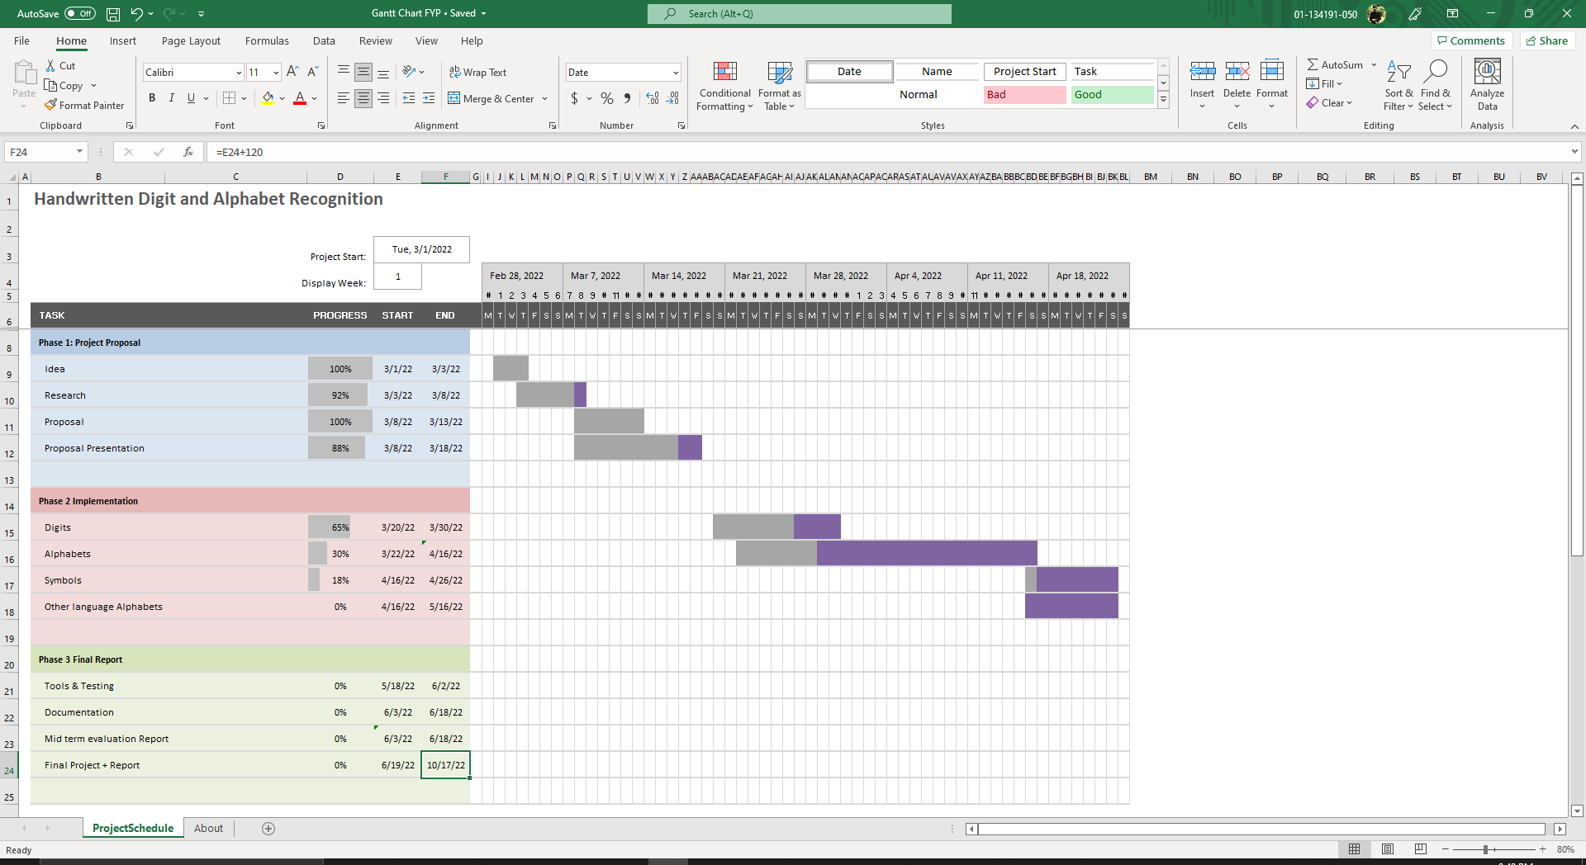

- References
Yugesh Verma, “problem statement for handwritten digit recognition”. November 8, 2021. problem statement for handwritten digit recognition | Projectworlds [1]

Mayur Bhargab Bora, “Handwritten Character Recognition from Images using CNN-ECOC”. April 16, 2020. Handwritten Character Recognition from Images using CNN-ECOC - ScienceDirect [1]

